**Project Design Phase-II**

**Data Flow Diagram & User Stories**

|  |  |
| --- | --- |
| Date | 31 January 2025 |
| Team ID | 153036 |
| Project Name | Rhythmic Tunes |
| Maximum Marks | 4 Marks |

**Team Details:**

|  |  |  |
| --- | --- | --- |
| Team Leader | Sowmiya P | bsccs.bcss2022@alphagroup.edu |
| Team Member 1 | Bhuvaneshwari N | bsccs.bcss2004@alphagroup.edu |
| Team Member 2 | Suguna N | suguna102004@gmail.com |
| Team Member 3 | Subha N | bsccs.bcss2023@alphagroup.edu |

**Data Flow Diagrams:**

A Data Flow Diagram (DFD) is a traditional visual representation of the information flows within a system. A neat and clear DFD can depict the right amount of the system requirement graphically. It shows how data enters and leaves the system, what changes the information, and where data is stored.

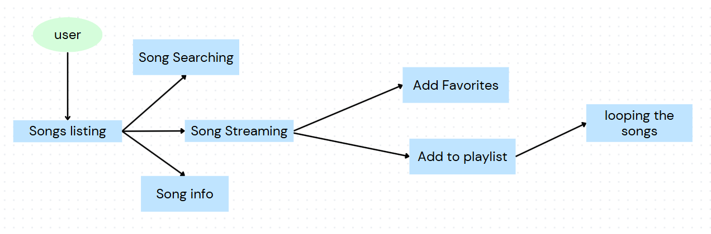

**User Stories**

**User Story Table – Music Streaming App**

|  |  |  |  |  |  |  |
| --- | --- | --- | --- | --- | --- | --- |
| **User Type** | **Functional Requirement (Epic)** | **User Story Number** | **User Story / Task** | **Acceptance Criteria** | **Priority** | **Release** |
| **Music Discovery** |  | USN-1 | As a user, I can search for songs, albums, or artists. | I can see a list of relevant search results. | High | Sprint-1 |
|  |  | USN-2 | As a user, I can view trending and recommended songs. | I can see recommended music on my dashboard. | Medium | Sprint-2 |
| **Playback** |  | USN-3 | As a user, I can play, pause, and skip songs. | I can control playback with basic buttons. | High | Sprint-1 |
|  |  | USN-4 | As a user, I can view album artwork and song details while playing a song. | I can see album art, song title, and artist name. | Medium | Sprint-2 |
| **Playlists & Favorites** |  | USN-5 | As a user, I can create my own playlists. | I can save a collection of songs under a custom playlist name. | High | Sprint-2 |
|  |  | USN-6 | As a user, I can add or remove songs from my playlists. | I can successfully manage songs within a playlist. | High | Sprint-2 |
|  |  | USN-7 | As a user, I can like/favorite songs. | I can save my favorite songs and access them later. | Medium | Sprint-2 |
| **Audio Streaming** |  | USN-8 | As a user, I can stream high-quality audio. | I can listen to songs without buffering. | High | Sprint-1 |